Task 2.

The test plan for the fitness tracker app, Pulse, is divided into 6 segments called “test-sets”; the emai/signupl tests, the password tests, log-out tests, log-in test, exercise-log tests, change-of-passwords & emails tests and the responsiveness tests.

- The Email/Signup Tests.

This test-set checks whether incorrect login details entered will still work. It also deals with whether it’s possible for the app to see that you have signed up by creating an account.

- Stage One of These Tests: This stage handles responsiveness of inputing two signup details, which are the username and email of the app’s user.

RESULT: The result was successful. The sign-up button works to enter the user’s details into the database of the app.

- Stage Two of These Tests: Thsi stage deals with whether the app can still see you as someone that has sign-up for it after you have closed and re-opened Pulse.

RESULT: The result was successful.

- The Password Tests.

This test-set checks for how well passwords are recognized after creating them during user sign-ups.

- Stage One of These Tests: This test is to verify whether the passwords will be rejected if they don’t have any of all punctuations on a keyboard, a capital letter or a number.

RESULT: The result was successful.

- Stage Two of These Tests: This test is to check whether the censoring function for the passwords works.

RESULT: The result was successful.

- The Log-out Tests.

This test-set is to see whether it is possible to log out of the Pulse fitness tracker app.

RESULT: The result was successful. It requires you to log-in to see your personal activity on Pulse after you log-out.

- The Log-in Tests.

This test-set is to see whether it is possible to log into the Pulse fitness tracker app.

RESULT: The result was successful.

- The Exercise-Logs Tests.

This test-set is to check how responsive features of a user’s log full of exercises are. This includes the progress in terms of steps taken, metres crossed etc, as well as which excercises where selected.

- Stage One of The Test Set: Whether exercises are registered into a user’s log after they are selected by clicking the button to pick them.

RESULT: The result was successful. The exercises are registered.

- Stage Two of The Test Set” Whether the real-time updates expected from performing the exercises after linking Pulse to your heart for monitoring the user’s heartrate are made.

RESULT: The result was successful. The real-time updates are made.

- Change of Passwords and Emails Test.

- Stage One of This Test Set: Checking if it’s possible for a user of Pulse to change his/her email.

RESULT: The result is a success. Users can change their emails.

- Stage Two of This Test Set: Checking if it’s possible for a user of Pulse to change his/her password.

RESULT: The result is a success. Users can change their passwords.

- Stage Three of This Test Set: Whether the change of email remains in effect when you reload pulse.

RESULT: The result is a success. The change is still in effect.

- The Responsiveness Test: This is to check if the Pulse fitness tracker app is responsive with all mobile devices. Phones, tablets, android watches and Apple ones were used for those tests. The results were successful, although more work can be done to make the app more responsive to watches.

The way the app isn’t fully responsive on those watches shows a discrepancy of the watch having weaker hardware.

Justifying The Test Plan.

After testing this app, it will do justice to verify why we had to go through the above stated procedure to test the Pulse fitness tracker:

- This app had to be checked for whether users can have the app as very retentive for storing their data because it will make it easier for people to come back to their progress, thus actually functioning with the app. What would be better to add is a guest mode, but it hasn’t yet been seen as necessary for an app to have this features without customers giving feedback on our prototypes yet. Nonetheless, a version of this app with the guest mode is made in preparation for release, just in case.

- Concerning data and password security, some may say that standards we set for the passwords are too far, because they may be scared that people won’t be able to remember their passwords and find themselves going back and forth with accounts, but not only is what we set 100% to make passwords harder to guess and hack for, but also there are even higher standards we intend to follow for later designs in the future. You log you out of your account automatically after closing the app or their website so that other users can’t easily access it after they carry your device.

- Real-time analytics of metrices concerning how exercises are perfomed are best for further studying feedback from them, rather than coding the metrices to be updated after the exercises are complete. Also even if some people will want their data from completed exercises to be hidden for security reasons, that’s a feature not added because we thought it would still help for the health-related reasons that we fore-saw users won’t be able to see yet. Nonetheless we can release later versions of this app with that feature.

- Yes, you guys heard it. We had to test for whether it will be possible to use the fitness app on all devices, even watches - the android and Apple ones. This is because it ensures that a sync with the user’s movement while simultanously holding a device whatsoever with the app running is possible. As stated earlier though, a foresight wasn’t seen of the weaker hardware of the referenced electronical watches than other devices being unable to make the Pulse fitness tracker compatible with it. Later updates of this app should fix that.

- So far so good, the app has done justice for functionality and retention of user data. At this rate, it will be safe to say that with these results, the fitness tracker can be released for use on every device but a smartwatch for now, but don’t worry, we’ll make it’s delivery to the public for those accessories as a prompt follow-up of the release of this app for other computers.

As for creating the test-plan like so, it makes it easier for other people to see how far we have gone with verifying the app for release, with simple and globally easy to read grammar.

Task 3.

Justifying The Class Diagram for the Pulse Fitness Tracker.

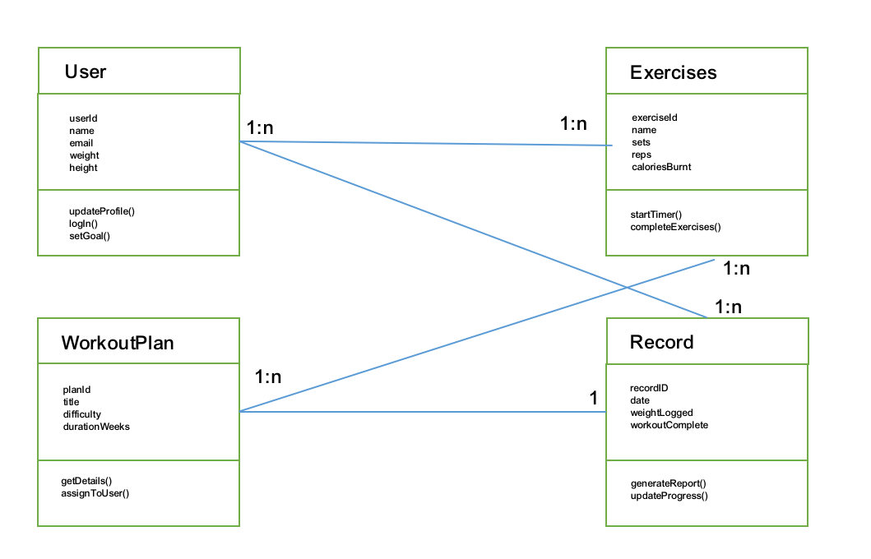Fig 1: Pulse’s Class Diagram.

A class diagram is a plan for the entities a program will need to be worked with, as well as their attributes, and in this case of app design, their methods. We need this class diagram simply because the reason we do is based on the definition of the class diagram - it is a blueprint of what we want to create and an outline for our goals for the program.

As shown in Fig1: Pulse’s Class Diagram, four major areas have been targeted for this fitness tracker. Before we get into discussing them, we could’ve had an entity for Nutrition, like we do for User, but we we’re cautious about making nutrition planning to obstruct the natural ones of some of our user, by chance. The four major areas here are User, WorkoutPlan, Exercises and Records.

The User’s attributes deals with data recorded about a user when opening his/her account on the app, or when using it. The WorkoutPlan’s attributes covers data about the exercises the user has selected to do, but the case is the user can plot a lot of exercises into one plan. The Exercises’ attributes is for keeping tabs on how they workout plans are designed. They contain metrices for making sure the goals for each plan is reached. The Record’s attributes are there for showing specific measures for how each workout plan was followed and completed. This can be retrieved by the user for evaluation of his/her progress and what more to improve on.

This diagram has been very helpful for the progress of this app because it made development of this app faster. As they say, fail to plan, plan to fail.

The diagram is also important for a few more reasons. Finding errors while working on the fitness tracker was easier with a plan like so. This makes things more tolerable to work with alongside developers.

With class diagrams like what we have have here, it will be more possible to communicate the foundation of what we want a program to look and funtion like. Documentation of the plans we have for more apps to come will make it feasible to reference what we will need for more, precisely the paramount template for a successful program.

At this rate, it can even be used to teach people learning coding how to plan works like this, so that in the future they won’t have to go back and forth after second the steps they take to code a program. With this, you should have a full knowledge of a class diagram’s creation.

